**Software Project Management Plan**

**For**

**Butterfly, Inc.**

**By**

**Makafui Dzeze**

**3/2/2020**

**Table of Contents**

1. Introduction

This project will be the creation of an ecommerce website that was derived from an idea I had about starting a strip eyelash company. This website will be selling eyelashes, coming in different styles, and eyelash accessories such as eyelash glue, tweezers, pocket mirrors.

1.1 Project Overview

The project objective is to create an ecommerce website. Using HTML, CSS, and Javascript, I will build the website. While this could be challenging since I have to integrate features that automatically alert me as the business owner when I need to restock on items and payment methods which will be handled by Paypal. The eyelash vendor will be Aliexpress. I may also use Wordpress instead to get a domain, which I will have to pay for. I may also use Wordpress to get a code template for my website, to optimize on time.

1.2 Project Deliverables

1- Part I: **Topic Proposal** due 2/9

2-Part II: **Repo SetUp** due 2/21

3- Part III: **Software Project Management Plan** due 2/25

4- Part IV: **Website Prototype**

1.3 Evolution of the SPMP

N/A

1.4 Reference Materials

TBA as I do more research (to be updated)

1.5 Definitions and Acronyms

TBA

Define or provide references to the definition of all terms and acronyms required to properly interpret the SPMP.

**2. Project Organization**

2.1 Process Model

The process that will be used for this project will be the Waterfall Model precisely because of its well-defined steps and tasks as these provide a structure that can be followed. Additionally, it provides the delivery of quality work on time, which is important to the successful completion of a project.

2.2 Organizational Structure

The project will be managed internally by me.

2.3 Organizational Interfaces

N/A

2.4 Project Responsibilities

|  |  |  |
| --- | --- | --- |
| Role | Description | Person |
| Project Manager/Point of Contact | Leads the team and handles the communications | Makafui Dzeze |
| Planner/documentation | Competes the various deliverables that are required by the client | Makafui Dzeze |
| Programmer | Completes the programming tasks in the team | Makafui Dzeze |

**3. Managerial Process**

3.1 Management Objectives and Priorities

|  |  |  |  |
| --- | --- | --- | --- |
| Project Dimension | Fixed | Constrained | Flexible |
| Cost |  | X |  |
| Schedule |  |  | X |
| Scope/Functionality |  |  | X |

3.2 Assumptions, Dependencies, and Constraints

Constraints:

1. There is a constraint on the budget since there will be no funding and anything that will need financing will be coming from me.

2. There is a loose constraint on time, despite the fact that the project is due at the end of the semester, there is time up to that time to work on the project and have it done.

Dependencies:

1. It will be dependent and rely on the server, hosting service, and certain APIs that I might use.

Assumptions:

1. The functionality of the website will be limited since it won’t be a real working website for a company.

2. The website will not be fully finished.

3.3 Risk Management

Describe the process to be used to identify, analyze, and manage the risk factors associated with the project. Describe mechanisms for tracking the various risk factors and implementing contingency plans. Risk factors that should be considered include contractual risks, technological risks, risks due to size and complexity of the product, risks in personnel acquisition and retention, and risks in achieving customer acceptance of the product. The specific risks for this project and the methods for managing them may be documented here or in another document included as an appendix or by reference.

3.4 Monitoring and Controlling Mechanisms

N/A

3.5 Staffing Approach.

N/A

**4. Technical Process**

4.1 Methods, Tools, and Techniques

The waterfall model shall be used for this software project. Tools to be used include Github, HTML, CSS, JavaScript (using libraries like React), and MySQL. Or perhaps, I will use a template from Wordpress and continue coding from there.

4.2 Software Documentation

I will provide documentation over the course of this project to allow myself to understand what is going on anytime in the code so that I can easily backtrack and trace my code. This will make debugging easier and will provide documentation for changes to be made in the future.

4.3 User Documentation

How would I go about doing this?

4.4 Project Support Functions

Testing after each cycle and customer criticism by giving the customer a testable product. Testing will be performed alongside quality affirmation tests. After creating a working product, the prototype will be sent to the customer to test and give feedback.

**5. Work Packages, Schedule, and Budget**

5.1 Work Packages

**WBS**

**USE CASE**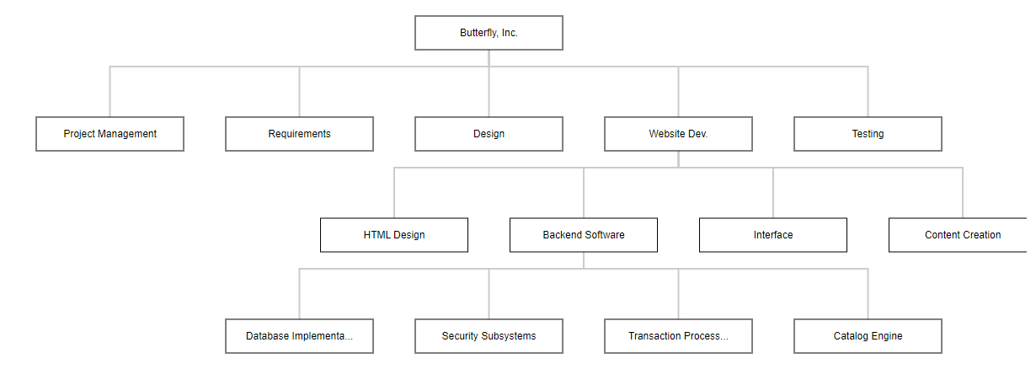

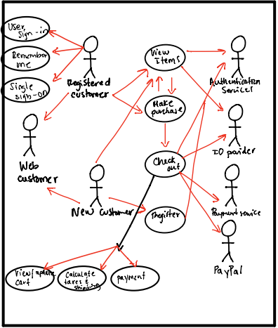

5.2 Dependencies N/A

5.3 Resource Requirements

N/A

5.4 Budget and Resource Allocation

N/A

5.5 Schedule

**Gantt Chart**

